**Second Project**

**Name Of the Project – Amazon Type Project**

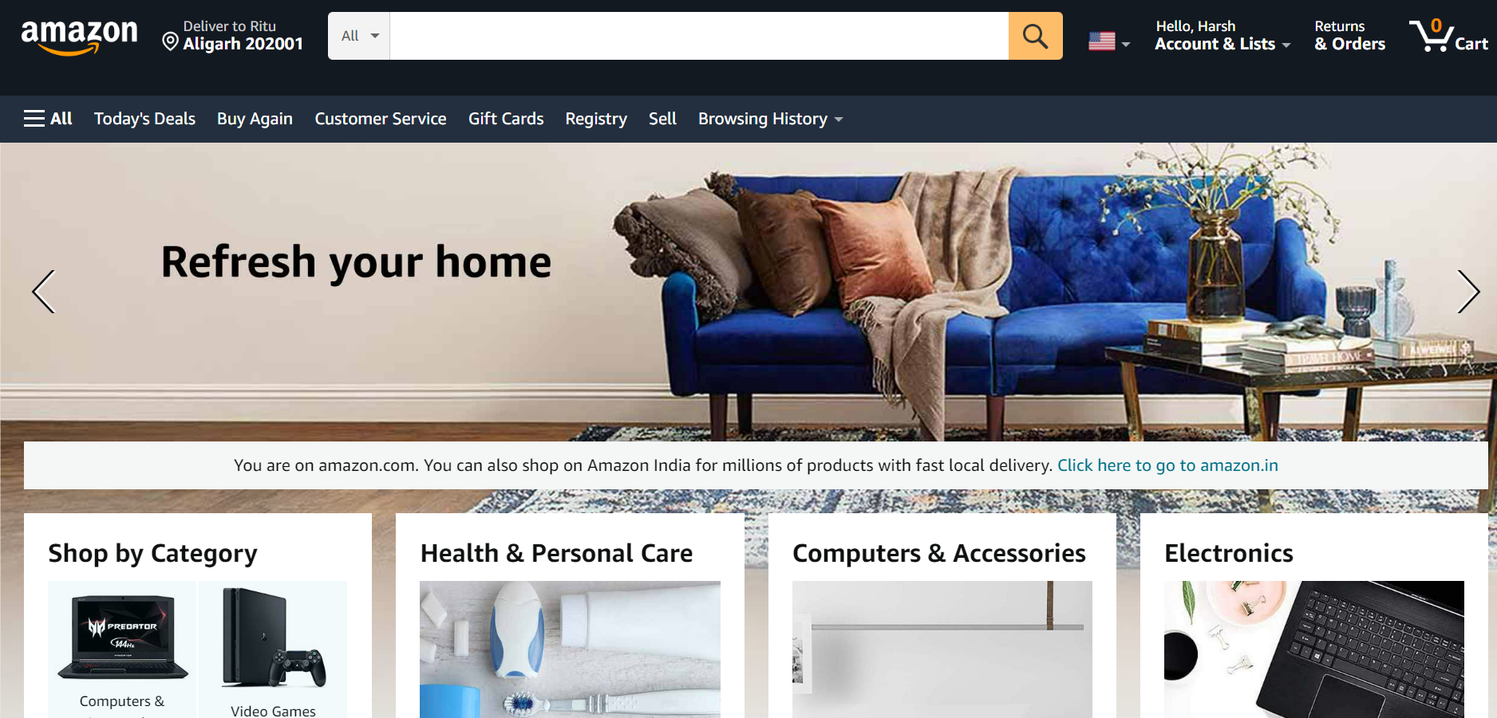

It will be an E-commerce website. The look of the website will be exactly like Amazon.

No. of Pages I will create.

1. Home Page
2. Registration Page
3. Listing Page
4. Details Page
5. Payment Page

**#Home Page**

#Navigation Bar

#Menu Bar

#Logo

#Search Bar

#Add to Cart

#Slider

#Trending Product (Best Seller, Top Seller Products)

#Footer Section

**#Registration Page**

#Registration Form (Name, Email Id 0r Phone no. and Password)

**#Listing Page**

#Filter (Rating & Review, Price Range, Brands, Size, Featured Products)

#Multiple Type Products and Category Wise Products.

**#Details Page**

#Product Details – Brand & Product Name, Image and Description. Price, Size & Color, Detailed Information, Customer Rate & Review.

#Add to Cart

**#Payment Page**

#Payment Option

#Customer Address & Contact Details